Future Technologies Industry Cluster
College of Vocational Education
Associate Degree in Information Technology AD006
COSC 2383 Advanced Networking 2
EAT IVR Extnv2 ANSWER SHEET
Semester 1 2023
This assessment task is worth 5% of your total grade
Name: Vu Nguyen
Student number S4010423
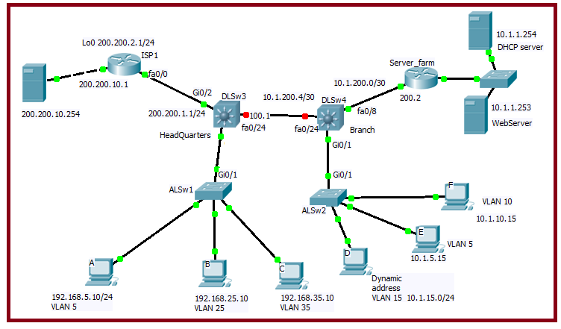

This assessment uses a Packet Tracer file, which you need to download from the Canvas.
The Packet Tracer file does not need to be completed. The Packet Tracer file is needed for important information (e.g. preconfigurations, server settings etc) Also, you may test your commands using the Packet Tracer file
Start by writing your name and student number on this document above.
Then, rename this file with your Name_Student ID (e.g. JOHN_1234567 EAT IVR Extn)
When it is time for you to submit your work, ONLY submit this answers sheet
Don’t submit the Packet Tracer file.

Task 1 InterVLAN Routing within the HQ domain 3 points

A On DLSw3 (HeadQuarters) configure Switched Virtual Interfaces (SVIs) to allow interVLAN communication between PCs A, B and C
The gateway address on the SVIs will be the first address in the network
3 points
A !On DLSw3 configure SVI for IVR
! DLSw3
interface vlan 5
ip address 192.168.5.1 255.255.255.0
no shutdown
interface vlan 25
ip address 192.168.25.1 255.255.255.0
no shutdown
interface vlan 35
ip address 192.168.35.1 255.255.255.0
no shutdown
ip routing

Task 2 InterVLAN Routing within the HQ domain 3 points

A On DLSw4 configure Switched Virtual Interfaces (SVIs) to allow interVLAN communication between vlans 5,10 and 15.
The gateway address on the SVIs will be the last address in the network

3 points
A !On DLSw4 configure SVI for IVR
! DLSw4
interface vlan 5
ip address 10.1.5.254 255.255.255.0
no shutdown
interface vlan 10
ip address 10.1.10.254 255.255.255.0
no shutdown
interface vlan 15
ip address 10.1.15.254 255.255.255.0
no shutdown
ip routing

Task 3 Enable layer 3 links 3 points
A Enable a layer 3 link between DLSw3 and the ISP1 router
Configure port Gi0/2 on DLSw3 as a routed port with the IP address 200.200.1.1

B Enable a layer 3 link between DLSw4 and the Server_farm router
Configure port fa0/8 on DLSw4 as a routed port with an appropriate IP address
3 points
A Configure port Gi0/2 on DLSw3 as a routed port with the IP address 200.200.1.1
!DLSw3
!the diagram shows it is a /24
int gi0/2

no switchport
ip address 200.200.1.1 255.255.255.0
no shutdown
B Configure port fa0/8 on DLSw4 as a routed port with an appropriate IP address

!DLSw4
!the diagram shows it is a /30
!the other end is 10.1.200.2
int fa0/8
no switchport
ip address 10.1.200.1 255.255.255.252
no shutdown

Task 4 Access to the company servers 2 points
2 points

A DLSw4 is to advertise its 3 VLAN networks to the server_farm router.
Use a single OSPF network statement .
!DLSw4
router ospf 1
network 10.1.5.0 0.0.15.255 area 0

! On the Server-farm router, troubleshoot the existing OSPF configuration
router ospf 1
log-adjacency-changes
network 10.1.1.1 0.0.0.0 area 0
network 10.1.200.1 0.0.0.0 area 0

Task 5 Access to the Internet for the HQ vlans 2 points
3 points
On DLSw3, configure a default route that points to the next hop router i.e. to the address of the ISP router
- On DLSw3, configure EIGRP on its link to ISP1 and also on its 3 vlan networks
Disable eigrp auto-summarization

A On DLSw3, configure a default route that points to the next hop router i.e. to the address of the ISP router.
!DLSw3
ip route 0.0.0.0 0.0.0.0 200.200.10.1

On DLSw3, configure EIGRP on its link to ISP1 and also on its 3 vlan networks. Use a single EIGRP network command.
!DLSw3
router eigrp 1
network 200.200.1.0 0.0.0.255
network 192.168.5.0 0.0.0.255
network 192.168.25.0 0.0.0.255
network 192.168.35.0 0.0.0.255
no auto-summary

Task 6 DHCP for the DLSw4 vlan 15 subnet 3 points

- The DHCP server at 10.1.1.254 is to be configured to provide dhcp for the VLAN 15 network, 10.1.15.0/24.
Create and modify the dhcp settings on the pool called V15_POOL. Paste a screenshot showing the dhcp settings on the server
- Configure the DLSw4 vlan 15 SVI to forward the dhcp broadcast from PC_D to the dhcp server
2 points
1 point for both changes => 10.1.15.254 and non zero max users, 1 point helper-address
A The DHCP server at 10.1.1.254 is to be configured to provide dhcp for the VLAN 15 network, 10.1.15.0/24.
Check and modify the dhcp settings on the pool called V15_POOL. Paste a screenshot showing the new dhcp settings on the server

B Configure the DLSw4 vlan 15 SVI to forward the dhcp broadcast from PC_D to the dhcp server
!DLSw4
interface vlan 15
ip helper-address 10.1.1.254

END of this assessed Task

